Testing Report
Settlement Desk

Run allocation matching Demo: Click button and they reload and an error indicate “Allocation rejected
allocation match failed: amount mismatch on leg cash
No partial commit — allocations on the deal unchanged. Correct the pledge to continue.
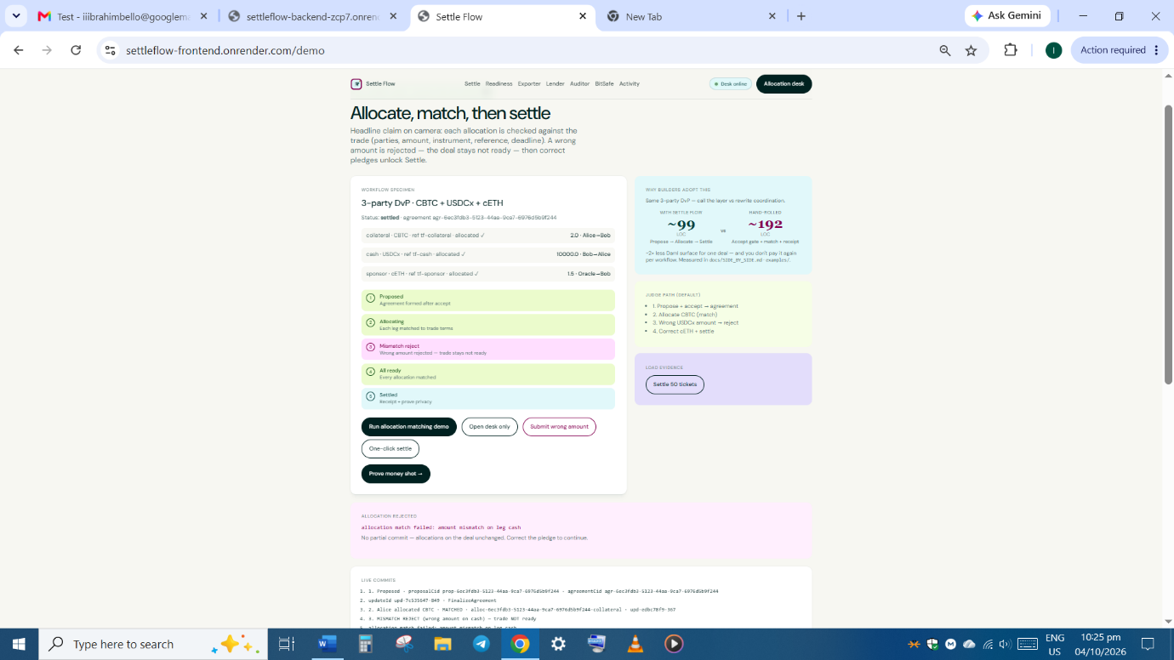

- Trade. Readiness
PRD §8 · FR-11 Status View (sS8 needs correction)
When you click on allocate all legs under settlement Readiness it indicate “Allocation failed:endpoint not found). Propose new trade button works well.
Screenshot below
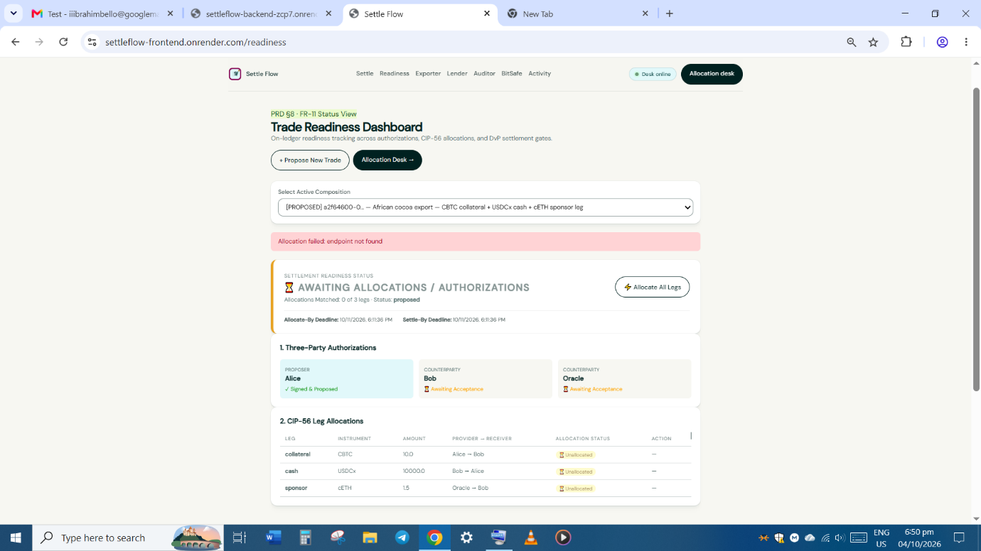

- A)Exporter Desk: initiate the DvP proposal-( Initiate proposal/Propose short-lived ticket/Propose broken ticket) button when clicked displace nothin

B)You are Alice. Stage the reusable 3-party settlement pattern: CBTC collateral, USDCx cash, and cETH. Cancel or expire before settlement if the market moves. Under your tick list on far right corner, when you click on settle now button you receive error . Check below screenshot. Is it that Exporter can only confirm cancel or expire that’s why the error message? Why is settle now button appear in the your ticket?
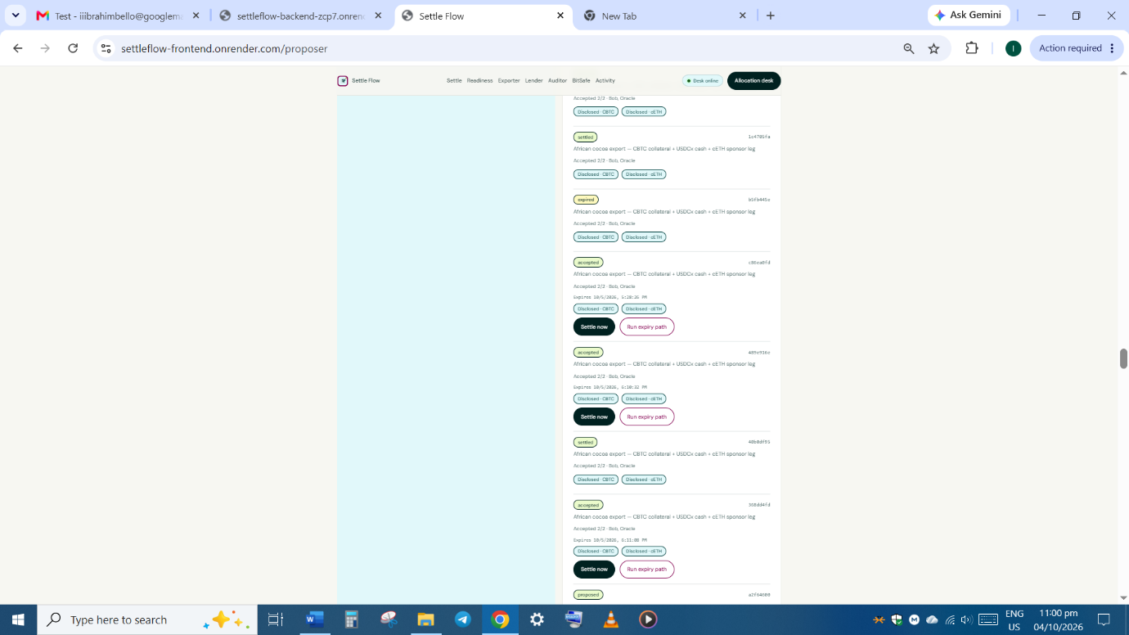

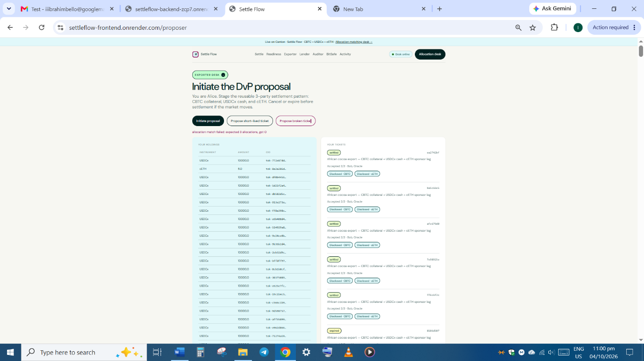

- A)BitSafe · 2-of-3→
Governed settlement refuses below threshold
Named governors Gov1, Gov2, Gov3. Threshold M=2. Attempt settle with too few approvals — the ledger refuses. Reach the threshold — it settles. One build, BitSafe + Track 1 payoff.
When you click on Open Gov deal, An error message. Screenshot below
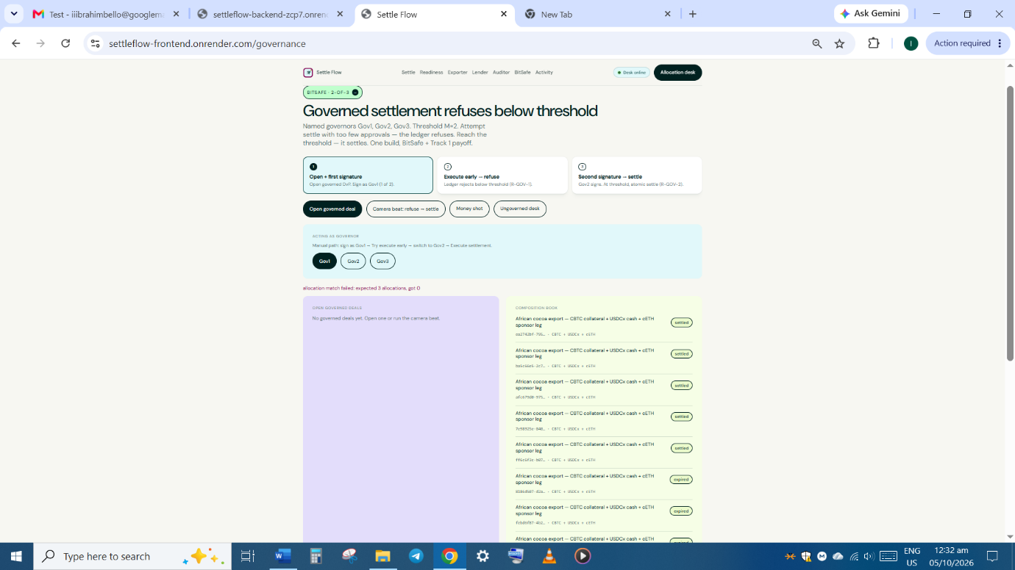

B) Acting as governor
Manual path: sign as Gov1 → Try execute early → switch to Gov2 → Execute settlement.
Gov1/Gov2/Gov3/ bottom does display anything

C) click camera beat: Refuse – Settle button and error prompt appears.
